

**Change Control Request**

**For**

**Gateway Mega Program | Biller Isolation**

**CR44-BIL – Bad Words**

Business Owner: Rick Squires

Line of Business: Customer Ops

Prepared by Priyamvada Sharma

Document Version 1.0

Date 03/14/2016

# Change Request

|  |  |  |  |
| --- | --- | --- | --- |
| **Change Request** | | | |
| **CR**  **# 44-BIL** | **CR Name** | **Requestor** | **Date Expected** |
|  | Bad Words | Chris Alcott |  |

|  |  |  |  |
| --- | --- | --- | --- |
| **Notification List**  **(Impacted Parties & Supporting Personnel)** | | | |
| **Name** | **Program/Project** | **Role** | **Email** |
|  |  |  |  |
| Robert Bolt | BIL | Prog Manager |  |
| John Bair | GO UI | Architect |  |
| Jonathan Andrews | GO UI | Architect |  |
| Michelle Schweitzer | GO UI | Prog Manager |  |
| Jim Crisman | BIL | Sr. Architect |  |
| Gareth Davis | GO UI | Architect |  |

|  |
| --- |
| **Change Request Description** |
| **Program / Project Requesting Change** |
| Gateway Ordering Phase 2 |
| **Change Request Description** |
| RDM intgegration of Bad Words into UI from SOLO. |
| **Source of Need / Problem** |
| Charter will open itself to potential legal liability |
| **Business or Technical Change Justification** |
| IT technical change to deliver on business CR 22. |
| **Impacted Areas (Programs, Projects, Applications)** |
| Gateway Ordering, Biller Isolation Enterprise, SOLO |
| **Solution Decsription**  Expose RDM data (Bad words) from SOLO thru Enterprise service to UI. Update RDM ETL routines to resolve end-date error. Add index(s) for performance as required. |
| **Priority**  High Medium Low |
| **Impact of Not Making Change** |
| Charter will open itself to potential legal liability |

|  |
| --- |
| **Impact Assessment** |
| **Impact on Program or Dependent Projects/Programs**  GO UI |
| **Level of Effort to complete Design, Development and SIT (LOE in calendar days):**  **Xavient:-**  Design – 3 days  SOLO – 3 days (Fix the ETL end date problem (1999)  Development – 3 days  SIT - 3  TMO - 3 days  **Total: 12 days**  **Amdoc is not required** |
| **Impact on Application Architecture**  Xavient |
| **Impact on Schedule**  None |
| **Impact on Budget**  None |
| **Impact on Resources**  None |
| **Assumptions** |

# Notes

From Jonathan Andrews…..

We had a meeting yesterday afternoon with Alcott, Hanrahan, L’Ecuyer, Kessler, et al to discuss persistence for Gateway going forward.  Our going-in position was that we would use the RDM Bad Words list as the first item to populate a new Gateway ODS.  Due to timing (and other) considerations, this will not be possible; we will need to retrieve the Bad Words list from SOLO to meet the GO R2 timelines.

This will involve creating and orchestrating calls through the UI, Web API, Enterprise Service,  and SOLO Data layers; I believe we can omit JESI for this call – Jim feel free to correct me if you think they need to be included.

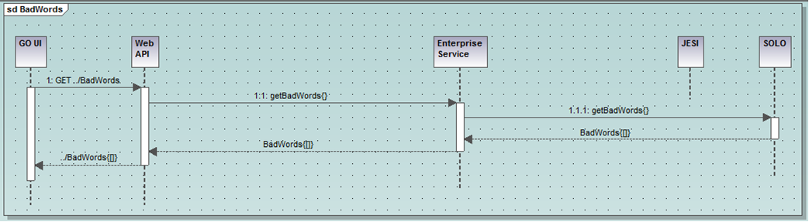

select description from t_rdm_reference_cd

where code_name = 'Bad_Words_List' *-- Redundant with code_set_id; use whichever is indexed*

and code_set_id = 11104 *-- Redundant with code_name; use whichever is indexed*

and end_date>sysdate; *-- Need to update ETL; current end_date for all values is 1999*

Approved by:

|  |  |  |  |  |  |  |
| --- | --- | --- | --- | --- | --- | --- |
| **Business Approval** |  |  |  | **IT Approval** |  |  |
|  |  |  |  |  |  |  |
|  |  |  |  |  |  |  |
|  |  |  |  |  |  |  |
| **Requestor** |  | **Date** |  | **Requestor** |  | **Date** |
|  |  |  |  |  |  |  |
|  |  |  |  |  |  |  |
|  |  |  |  |  |  |  |
| **Requestor** |  | **Date** |  | **Requestor** |  | **Date** |
|  |  |  |  |  |  |  |
|  |  |  |  |  |  |  |
|  |  |  |  |  |  |  |
| **Requestor** |  | **Date** |  | **Requestor** |  | **Date** |
|  |  |  |  |  |  |  |
|  |  |  |  |  |  |  |